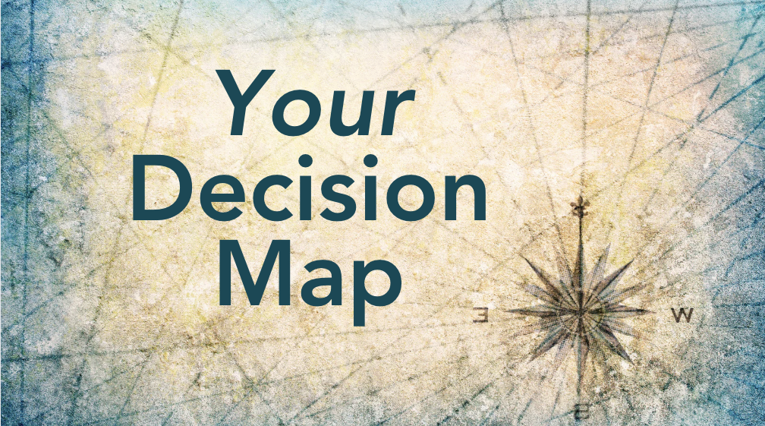

Making life changing choices with clarity, wisdom, and integrity

Making a big life decision ~ whether about your marriage, career, health or where you are living ~ is understandably very challenging.

The consequences of some loss and the impacts on others are potentially painful to face. It is easy to stall or get stuck.

And yet, the longer we hold off on deciding, the more we deny ourselves and potentially cause unintended harm (to our happiness and health and even to others by being not fully invested in the status quo).

On the flip side, the rewards of navigating change that is overdue in a sure footed and wise way can be life changing and confidence boosting.

This map will help you to see what steps are needed ~ and in which correct order ~ to come to making a wise and sustainable decision you will feel at peace with.

Check off any step(s) you have taken
(or underline if you are working on them currently)

!!! Notice if you have skipped any that are vital to complete prior.

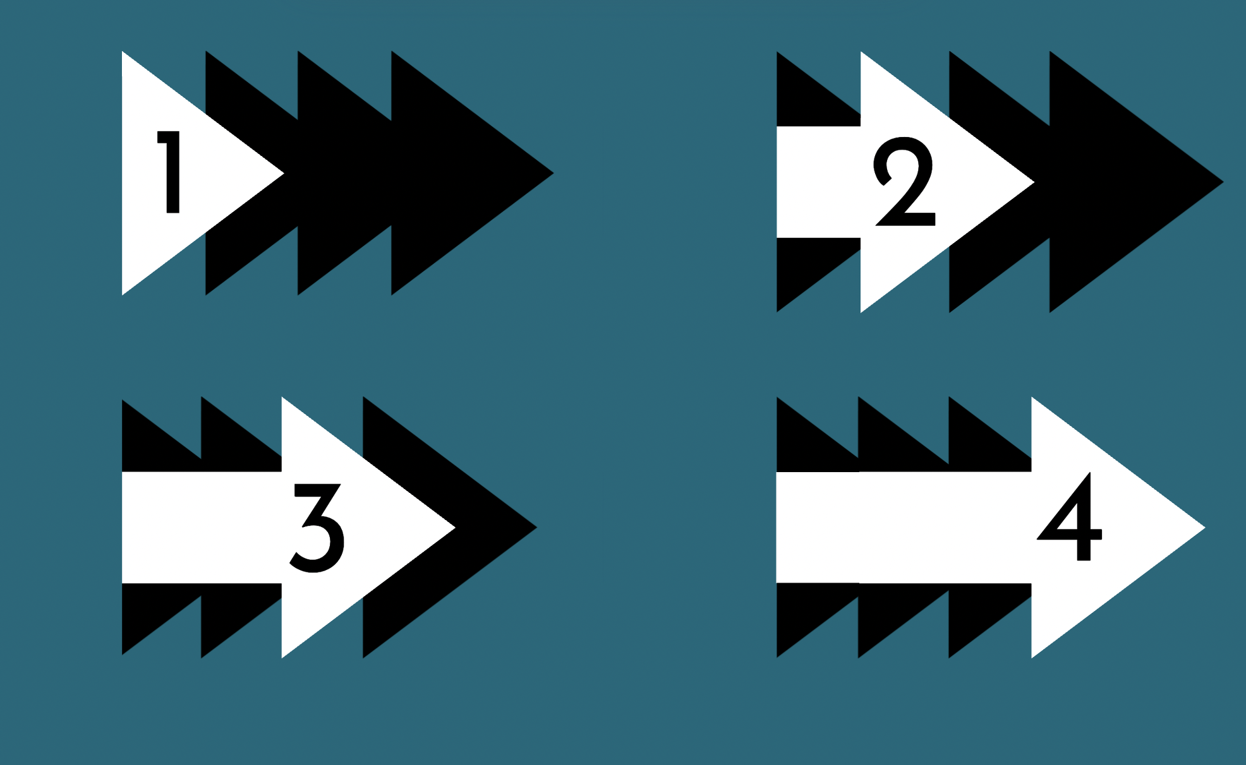
Phase DREAMING

This is a vital stage for discovery and in giving yourself the time and space to really consider what you are longing for and what your current situation offers and denies you.

👣 Key STEPS you need to take…

- Validated what is not working and missing
- Flushed out your core values (both cherished and denied)
- Clarified what you really want (Vision)

⚠️ PITFALL(s) to avoid!
- Getting stuck in only complaining about status quo.
- Focusing what you think you should want and comparing your situation to what others have.
- Skipping this phase, to rush ahead and try to be practical.

✅ COMPLETED when…
- You have clarity about top 3-5 values and what is most missing.

Phase DISCERNING

At this stage, you start confronting realities as well as sorting through all the possible doors you might walk through. It is not time to decide but to sift through and weigh with awareness and acceptance.

👣 Key STEPS you need to take…

- Listened to all the parts of you
Taking input in from different perspectives, noting emotional reactions and
the potential pros and cons.

- Gathered all data that is available
Checking options and assumptions, taking in realities of others who have made
similar choices all to expand your sense of what is possible and realistic.

- Called in Council of Allies and Advisor(s)
Exposing blind spots and helping you to see possibilities and realities clearly.

⚠️ PITFALL(s) to avoid!
- Only listen to parts of you that are loud…
- Did not do real world research – relying on online surface glances.
- Listening to everyone with an opinion.
- Getting no seasoned and wise guidance externally.

✅ COMPLETED when…
- You have taken in and evaluated all the data (internal and external) you could gather in the set time.
Phase DECIDING (Wisely)

This is a critical stage where it is tempting to jump the gun.
Taking time to process and digest fully, align all the parts of yourself around one choice and stepping into it in a decisive and clear way for everyone involved.

👣 Key STEPS you need to take…

- Made Executive Summary of Most Viable Path
Putting all the pieces together in a clear and comprehensive way, highlighting
the leading decision, why you would make it and all the potential impacts.

- Enlisted Buy-in from all parts
Dialoguing, reassuring and contracting with all parts of your self to ensure no
sabotage and full commitment behind leading decision.

- Decided and declared what, when and how…
Communicating a clear statement about the decision, your awareness of
potential impacts on others, when it goes into effect and how you will enact it.

⚠️ PITFALL(s) to avoid!
- Pressuring and coercing yourself to “just decide already!”
- Ignoring certain realities (limitations and costs) with wishful thinking.
- Avoiding your own emotions (fears, doubts and grief).

✅ COMPLETED when…
- You have made a decision and have started taking *irreversible action.
* actions that have set events in motion and which make it less easier to go back to the status quo. This does not mean you cannot revisit your decision or return to a previous context (if that proves wise later) but the momentum of the choice you made is made definite.

Phase DOING

At this stage it is all about living into the decision, dealing with second guessing, regrets and putting your full and honest efforts into seeing where this path takes you, while also being nimble and willing (over time) to recalibrate and adjust your course.

👣 Key STEPS you need to take…

- Digesting It Emotionally
Making space to feel any emotions that arise – ie, doubt, grief, shame, guilt & fear –
allows you to learn from your decision and understand yourself more profoundly.

- Daily Re-commitment
New patterns can feel unfamiliar and it is easy to slide back into old ways of being.
Step more fully into your choice daily allows you to truly discover where it leads.

- Re-evaluating and micro-pivoting
Consider that no path is perfect in meeting all of our needs and expectations.
Making small adjustments allows us to make our reality fit into the vision we had.

⚠️ PITFALL(s) to avoid!
- After avoiding previous steps, you waffle and ruminate in regret.
- You freak out and try to undo your decision to go back to your previous status quo before giving this new reality an honest try.

✅ COMPLETED when…
- You have built momentum in living through your decision and learning* from it. *You may decide to make a radical new decision (like returning to ___ ) yet you carry new awareness and a clarity about how to make the next path more successful.

NOW WHAT?

Whatever stage and steps you are on, ask yourself…

What is the best next step right now to pave the way for you to be moving forward with grace and more ease towards
making a wise decision that you feel at peace with?

- Reaching out to your own existing allies and advisors
  - ___________________________
  - ___________________________

- Discuss working with us (David Jurasek and Kathy Kaprino) 1-1.

- Consider At The Crossroads program which helps you to take each step on your decision map with seasoned guidance and compassionate peer support over 3 months.

To be announced at our Big Life Decisions” workshop
on Friday, Nov. 21st, 2025 from noon - 1:30pm (EST).

If you are not yet registered, go here.

